Department of Computer Science and Engineering

BRAC University

CSE 260: Digital Logic Design

Experiment # 7
Design a circuit that outputs 2’s complement of a 3 bit number using encoder & decoder.
IC: 74ls138 [decoder]; 74ls148 [encoder]
The Truth Table for 2’s complement output:

Inputs |  |  |  | Outputs |  |  |  | Active Low Output |  |  | Output line Connection
Minterm | C | B | A | Minterm | D₂ | D₁ | D₀ | D2 | D1 | D0 | Decoder | Encoder
0 | 0 | 0 | 0 | 0 | 0 | 0 | 0 | 1 | 1 | 1 | 0 | 0
1 | 0 | 0 | 1 | 7 | 1 | 1 | 1 | 0 | 0 | 0 | 1 | 7
2 | 0 | 1 | 0 | 6 | 1 | 1 | 0 | 0 | 0 | 1 | 2 | 6
3 | 0 | 1 | 1 | 5 | 1 | 0 | 1 | 0 | 1 | 0 | 3 | 5
4 | 1 | 0 | 0 | 4 | 1 | 0 | 0 | 0 | 1 | 1 | 4 | 4
5 | 1 | 0 | 1 | 3 | 0 | 1 | 1 | 1 | 0 | 0 | 5 | 3
6 | 1 | 1 | 0 | 2 | 0 | 1 | 0 | 1 | 0 | 1 | 6 | 2
7 | 1 | 1 | 1 | 1 | 0 | 0 | 1 | 1 | 1 | 0 | 7 | 1
0

1

2
0

1

2
0
1
2

3
4
5

6
7
0
1
2

3
4
5

6
7
3*8
decoder
8 to 3
encoder
Report:

The report should cover the followings
- Name of the experiment
- Objective
- Required Components and Equipments
- Experimental Setup (i.e., diagram of the circuit)
- Results and Discussions
  - Draw a circuit diagram with encoder and decoder that will output the 1’s complement of 3 bit number.
  - Can you implement a code converter with encoder and decoder? If yes, how? If no, explain why not?
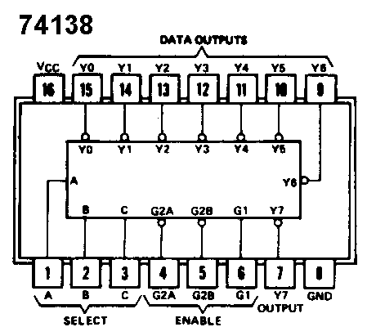

74148

